Skills Workshop # 3: Ethics in Research Workshop

Speaker: Dr. Anant R. Kukreti, Director for Engineering Outreach for the College of Engineering and Applied Science, Professor in the Department of Chemical and Environmental Engineering
Date: Tuesday, June 20, 2018
Time: 9:00 - 10:00 am
Venue: University of Cincinnati, Swift Hall, Room 608

Prepared by:
Marie Pollitt, Felicity-Franklin Middle School, Felicity, Ohio
RET Participant for Project #4: “Air Quality Air Quality Monitoring and Emissions Characterization Near a Major Railyard”

Dr. Anant Kukreti provided a workshop on Tuesday, June 20, 2018 from 9:00 – 10:00 am at the University of Cincinnati in Swift Hall, Room 608. Dr. Anant Kukreti is the Director, Engineering Outreach for the College of Engineering and Applied Science as well as a Professor in the Department of, Chemical and Environmental Engineering.

Dr. Kukreti began his session by giving an overview of the importance of research ethics. He emphasized the importance of not fudging your data, misleading people, taking money to get the “right” answer, or trying to profit from your research. There have been many unethical research situations that have occurred in regards to conducting research. A few documented situations included experiments on human subjects, acceptance of gifts or research support, burying “bad” results, disclosure of unverified results, and intentionally misleading research for political reasons.

There were two big issues addressed in his session: misconduct and unethical behavior. Misconduct is knowingly falsifying data for personal gain. Honest errors are not considered misconduct as long as the intent was not to deceive. If research misconduct occurs, it can lead to job discipline as well as legal punishment. Unethical behavior on the other hand is not necessarily misconduct. Errors in data are not unethical behavior, but not reporting the error can result in a punishable offense. If the error is proven to be harmless, it will probably not receive a consequence.

Dr. Kukreti introduced thirteen guiding principles adopted from David B. Resnik, J.D., Ph.D., that addresses various codes and policies: honesty, objectivity, integrity, carefulness, openness, respect for intellectual property, confidentially, responsible publication, responsible mentoring, respect for colleagues, social responsibility, non-discrimination, competence, legality, and animal care. In regards to honesty, Dr. Kukreti iterated the importance of disclosure (see Figure 1). Although data may have to be manipulated to eliminate incorrect data, clear records of the original data and complete disclosure of the findings need to be revealed. Objectivity is admitting and minimizing bias because all humans have biases, prejudices, and preconceived notions. He reviewed two topics related to integrity: conflict of interest and bias. He emphasized that a Conflict of Interest form must be signed and that salary is not considered to be a conflict of interest but doing research for money is unethical. Carefulness can be obtained by keeping a journal which will help avoid careless errors and negligence. Openness is achieved by sharing information while simultaneously being mindful of confidentiality agreements.

Figure 1: Importance of Honesty

Dr. Kukreti stated that a key component of respecting intellectual property is to give credit if you are using someone’s research (see Figure 2). It was noted that because there are those that steal other’s work, it is not advisable to disclose information before the owner of the research is ready. Publications are used to advance research and scholarships, not your career, therefore one should not produce redundant publications leading to publishers not accepting future papers any longer. Dr. Kukreti urged participants to have respect for colleagues and engage in responsible mentoring. It is not ethical to misuse those under you; for example, treat them as an indentured servant or threaten withholding graduation or tenure. Social responsibility is to report the findings of all research, even the if it contradicts the sponsor’s interests. As a professional, maintain and improve competences by going to conferences and reading research. In addition to nondiscrimination and legality Dr. Kukreti also spoke of human subject and animal care/protection. Prior to conducting human subject research, the Institutional Review Board (IRB) must approve. The protocol also calls for the IRB to be filed and followed. All human subjects must be informed of the research, their level of involvement, the objective of the research, how the data will be used and the opt-out clause even if the they are not involved in direct testing (see Figure 3).

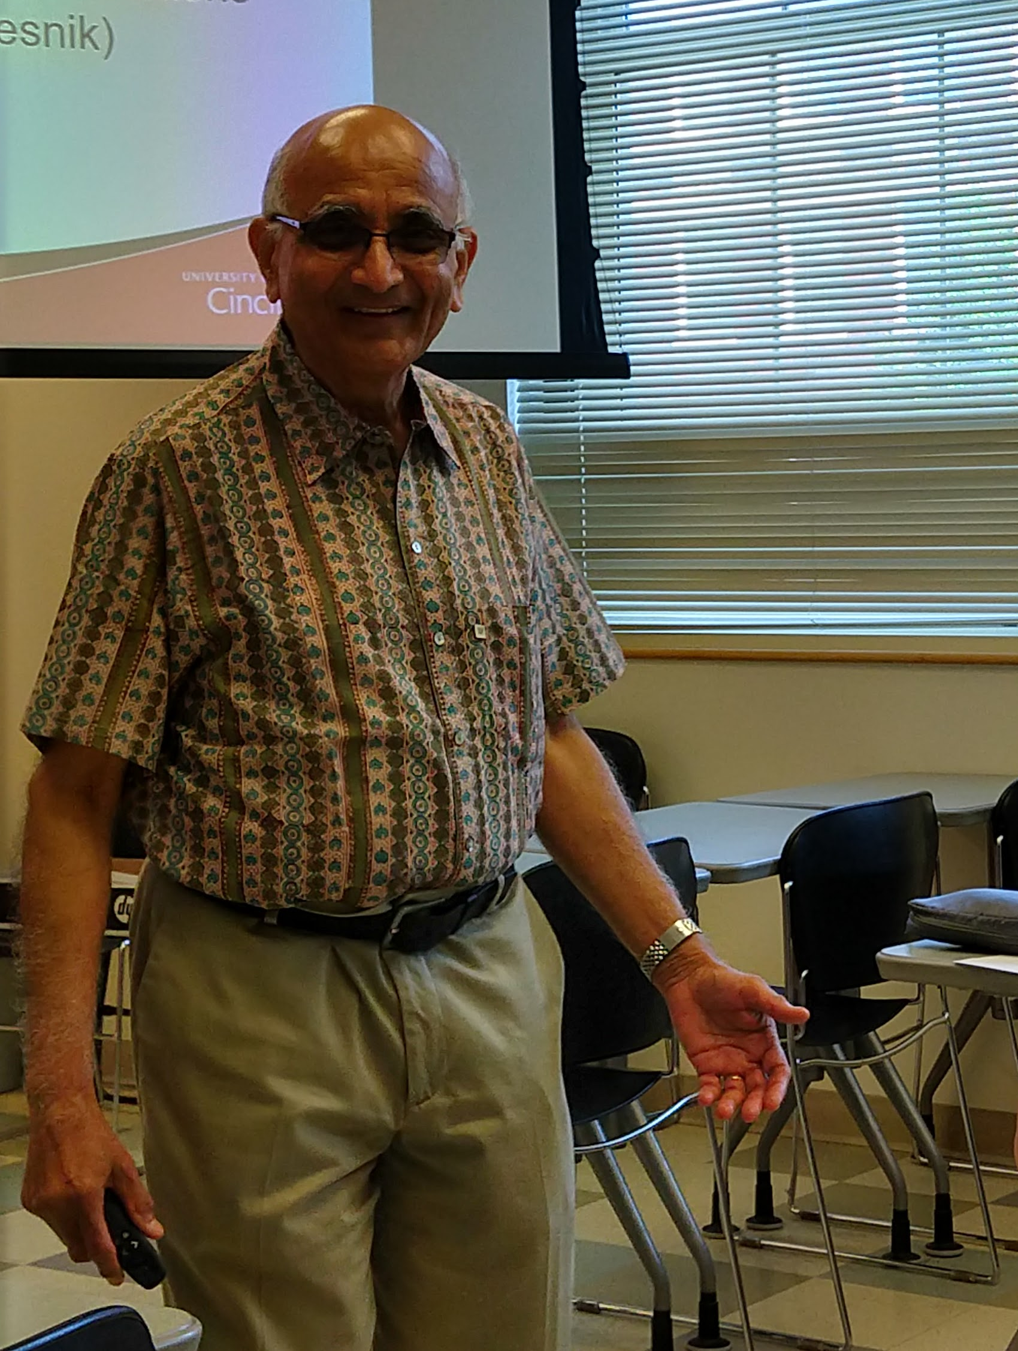  Figure 2: Discussing Plagiarism | 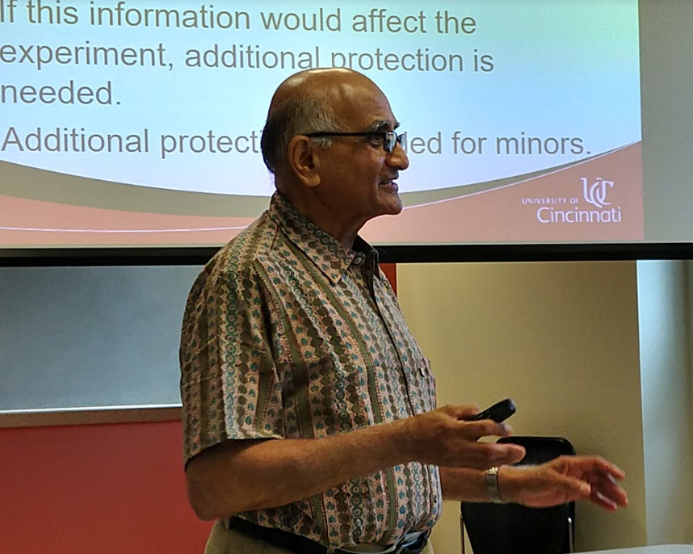  Figure 3: Essentials of Human Subject Protection

During the closing, Dr. Kukreti reiterated the ethics of research. He stated: “Disclosure is key. As long as people are aware of the data analysis/manipulation, bias, and conflict of interest you are probably OK.” He concluded with guidance on obtaining an IRB approval for human subjects.

